*Game Design for the Summer 2019*

**(BOLD text are suggested next tasks)**

**TODOs:**

* Lol get started
* Learn HTML, CSS, Javascript (jonathan: Still need to learn js)
* (jonathan): Learn sprite animation
* Initial Project Setup
  + ~~Setup git repository and access for Jonathan and David~~
  + **Create skeleton project that’ll run a simple “hello world” JS app. This will give Jonathan a framework to start creating animation tests.**
  + Game will initially run on local machine
* Initial goals
  + Simple one-level Pac-Man game where game board is represented by simple text file format
  + AI ghosts (Blinky, Pinky, Inky, Clyde)
  + Fruit bonus
  + Pellets and Power pellets
  + Graphically influenced by original pac-man.
  + Sound effects
  + Level start music
  + Constraints
    - No scoring/high scores.
    - No 1 or 2 player modes
    - 3-lives, no 1-ups
* Design Phase
  + Create game rules and objectives (not hard since we already know pac-man)
  + Create design document describing the overall architecture of the game logic.
  + Define project milestones and target dates.
    - We can define a minimum viable product (MVP) that is just a subset of the above “Initial Goals.” But hitting every goal will be our objective. Our milestones will be ordered in a way that will let us hit the MVP sooner than later.
  + Assign project responsibilities

**Completed Tasks:**

* HTML doc for website menu and game up. Style choices up for debate but can be worked on later.
* Added sample code to test with, learn from, and build on. We can start adding test features we know will be useful for a pac-man game.

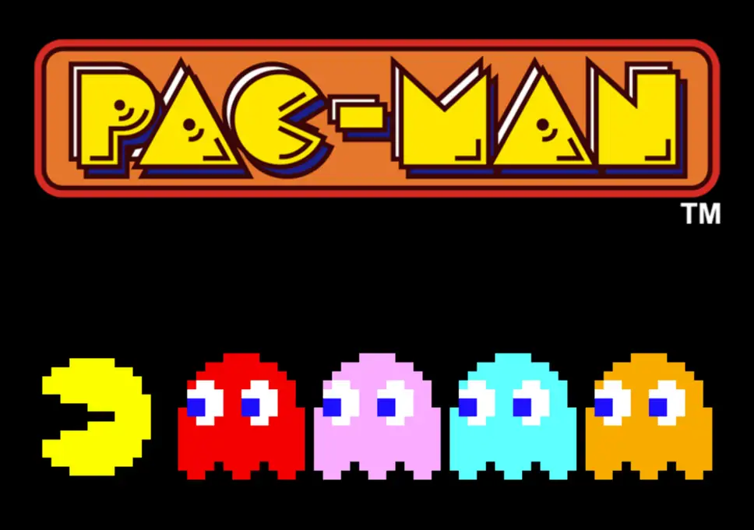

**Ghost AI Explained:** <https://www.youtube.com/watch?v=ataGotQ7ir8>

https://github.com/rm-hull/big-bang/tree/master/examples/pacman